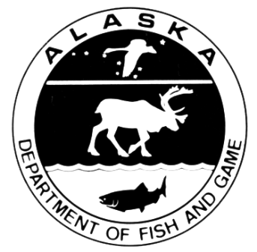
Issued: April 3, 2018
For Immediate Release
P.O. Box 115526
Juneau, AK 99811-5526
www.adfg.alaska.gov
Alaska Department of Fish and Game
Sam Cotten, Commissioner
Division of Sport Fish
Tom Brookover, Director
Anchorage Headquarters Office
333 Raspberry Road
Anchorage, AK 99518

Division of Sport Fish
News Release

Contact: Bob Chadwick, SE Regional Management Coordinator
(907) 747-5551; bob.chadwick@alaska.gov

KING SALMON SPORT FISHING REGULATIONS IN EFFECT FOR SOUTHEAST ALASKA

New 2018 sport fishing regulations for king (Chinook) salmon in Southeast Alaska and Yakutat will be in effect 12:01 a.m. Thursday, April 5, 2018 through 11:59 p.m. Friday, May 3, 2019. The regulations are:
- The bag and possession limit (resident and nonresident) is one king salmon 28 inches or greater in length;

- For nonresidents, annual harvest limits and recording requirements apply as follows:
  - From January 1 through June 30, the annual limit is three king salmon 28 inches or greater in length;
- From July 1 through December 31, the annual limit is one king salmon, 28 inches or greater in length, and any king salmon harvested from January 1 through June 30 will apply toward the one fish annual limit;
- Immediately upon landing and retaining a king salmon a nonresident must enter the species, date and location, in ink, on the back of their sport fishing license or harvest record.

- From October 1, 2018 through March 31, 2019; resident sport anglers may use two rods while fishing for king salmon; a resident using two rods may only retain king salmon.

King salmon regulations for the Haines, Skagway, Juneau, Petersburg, Wrangell, and Ketchikan and Ketchikan areas, announced on March 29, 2018, remain in effect to protect wild Alaska king salmon stocks.

The Alaska Board of Fisheries approved action plans for three king salmon Stocks of Management Concern (Unuk, King Salmon, and Chilkat River stocks) at the 2018 Southeast and Yakutat Finfish Meeting. Additionally, the 2018 king salmon forecasts indicate runs to other Southeast Alaska systems, particularly to the Stikine and Taku rivers, will be at an all-time low. Therefore, the Alaska Department of Fish and Game has imposed a 10% reduction to the Pacific Salmon Treaty king salmon all-gear harvest limit in 2018 and as a result, some of the management actions for 2018 will be more restrictive than those described in the action plans for all user groups. Management actions are being taken across all Southeast Alaska fisheries, including sport, commercial, personal use, and subsistence, to reduce harvest of wild king salmon.

The Basis for 2018 Chinook Salmon Conservation Measures in Southeast Alaska:
- Basis for 2018 Chinook Salmon Conservation Measures in SEAK pdf

For further information regarding sport fisheries in Southeast Alaska, contact the nearest ADF&G office or visit: http://www.adfg.alaska.gov/index.cfm?adfg=fishingSportFishingInfo.eonr

